5.4 Green’s Theorem

In many ways Green’s Theorem is the Climax of MTH 202 because it unites the concepts of partial differentiation, double integrals, and line integrals. In order to fully understand the statement of Green’s Theorem we must go over one more concept.

Definition: The positive orientation of a simple closed curve C refers to a single counterclockwise transversal of C. So, if C is given by the vector function where and D is the plane region that is bounded by C, then the region D is always on the left as the point traverses C.

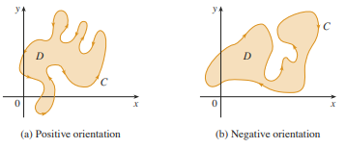

Example 1: Give a parameterization of the unit circle so that the curve given by your parameterization has positive orientation.

Theorem (Green’s Theorem): Let C be a positively oriented, piecewise-smooth, simple closed curve in the plane and let D be the region bounded by C. If P and Q have continuous partial derivatives on an open region that contains D, then .

Notation: The notation is sometimes used to indicate that the line integral is calculated using the positive orientation of the closed curve C.

Notation: Another notation for the positively oriented boundary curve of D is . So, one could write: .

Example 2: Evaluate where C is the triangular curve consisting of the line segments from (0,0) to (1,0), from (1,0) to (0,1), and from (0,1) to (0,0).

While the above shows how Green’s Theorem would work, we have yet to provide any sort of justification that this idea is actually valid. Now we provide a partial proof of Green’s Theorem.
Theorem (Green’s Theorem): Let C be a positively oriented, piecewise-smooth, simple closed curve in the plane and let D be the region bounded by C. If P and Q have continuous partial derivatives on an open region that contains D, then .

Green’s Theorem is quite difficult to prove in general, but we will give a proof for the special case where the region D is both type 1 and type 2. We will refer to such regions as simple regions.

Partial Proof of Green’s Theorem When D is both Type 1 and Type 2:

Example 3: Evaluate where C is the circle of radius 2 centered at (1,5).

Example 4: Suppose that C is a positively oriented, piecewise-smooth, simple closed curve in the plane and suppose D is the region bounded by C. TRUE or FALSE: yields the area of D.

A Generalization of Green’s Theorem:
Green’s Theorem can be generalized to apply to regions with holes, that is, regions which are not simply connected. Consider the following situation:
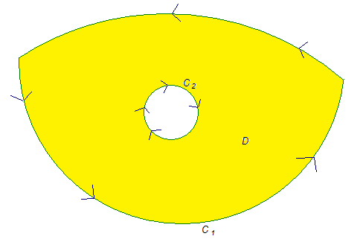

Suppose we want to find where P and Q have continuous first order partials on a region containing D. To do this we divide up the region D as follows.


Example 5: Suppose that is the unit circle with counterclockwise orientation. Suppose that is the circle centered at the origin with radius 2 and with counterclockwise orientation. Let C be the positively oriented curve given by .

- Sketch a picture of C and the region that it encloses.

- If , calculate .

